A000-AM,C-Taino-Cohoba Snuff Tube-Marble-1000 CE

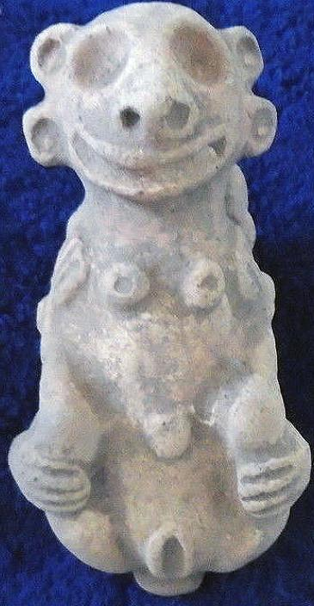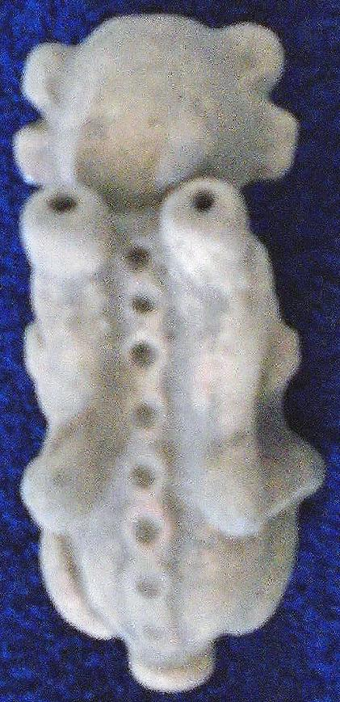

AM,C-Taino-Cohoba Snuff Tube-Marble-1000 CE

Case No.: 18

**Accession No.**

**Formal Label:** AM,C-Taino-Cohoba Snuff Tube-Marble-1000 CE

**Display Description:**

This sculpture of a cemi is an intermediary of YaYa, the Taino unknowable and hidden deity, Like O‘ Theos or YHWH. However, it can be known simultaneously through the effects it has on the material world. In this case, the the effects of the hallucinogens known by their Taino name cohoba.. For instance, cohoba snuff made from the seeds of the *Anadenanthera* tree of which the active hallucinogenic chemical is [bufotenin](https://en.wikipedia.org/wiki/Bufotenin) (5-HO-DMT, bufotenine) a tryptamine is related to the neurotransmitter serotonin. It is an alkaloid found in the skin of some species of toads. In effect this transforms the Bohique into YaYa intermediary. In Taíno religion, therefore, just as in Hebrew religion or Roman Catholicism there is need for intermediaries between the known and the unknowable, and these are the cemís, which are known and have been represented in their material form, providing another very important window on the spiritual world of the Taíno.

**Taino Cemi’s were embodiments of the** hidden god, YaYa, who was believed to be an immaterial spirit and whose name is a double superlative of the Arawak *Ia*, “spirit, essence, primary cause of life” or IaIa or YaYa, which can be translated as Spirit of Spirit (C. H. de Goeje, *The Arawak language of Guiana,* Amsterdam, 1928, pp. 45, 142, 204), and whom Father Pané says his “name is a name they do not know” (Pané, Account, ch IX). This is a sophisticated approach to a metaphysical entity that simultaneously exists as a primary cause and is unknowable. The Taíno believe that this entity “is in heaven [an Indo-European, Roman Catholic concept which has no immediate cognate in Taíno] and is immortal and that no one can see it and that it has a mother [which means a genesis] but no beginning” (*Relación* 21). This last statement if put in its stark simplicity it would be: “YaYa has a genesis but no beginning.”

**Taíno Cemieism and Taino Religion.** Taíno cosmology, religion and its rituals is described in Fray Ramón Pané’s *An Account of the Antiquities of the Indians*, the most important anthropological document on the Taíno that contains a wealth of information on this extinct culture. His commission from Columbus required him to record the Taíno beliefs and ceremonies as accurately as possible, and to that end he lived among the native Taíno population from 1493 to 1498. However, he was also a product of fifteenth century Roman Catholicism, and his primary goal was to convert the Taínos whom he regarded as heathens and idolaters. “[Some] were inclined to believe easily. But with others there is need for force and ingenuity because we are not all made of the same stuff. Although those people made a good beginning and a better end, there will be others who will begin well and afterwards will laugh at what has been taught them; with them there is need for force and punishment” (Pané p. 38).

**LC Classification:**

**Date or Time Horizon:**

**Geographical Area:**

**Map:**

**GPS coordinates:**

**Cultural Affiliation:**

**Media:**

**Dimensions:**

**Weight:**

**Condition:**

**Provenance:**

**Discussion:**

**References:**

# Order details

## Sales order

Sold by [heratony](http://myworld.ebay.com/heratony) ( [4608](http://feedback.ebay.com/ws/eBayISAPI.dll?ViewFeedback&userid=heratony) )

### Delivery package 1 of 1

Estimated delivery Tuesday, Apr 5, 2016

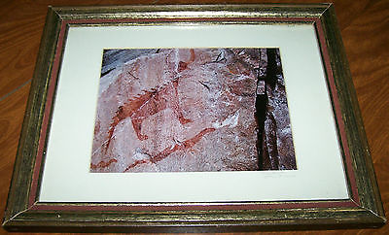

#### [Original Signed Matted Photograph Nature Wildlife PICTOGRAPH LAKE SUPERIOR 11x14](http://www.ebay.com/itm/201468173933)

|  |  |
| --- | --- |
| Item price | $12.00 |
| Quantity | 1 |
| Item number | 201468173933 |
| Shipping service | USPS Parcel Select Ground |

## Sales order

Sold by [guayacanex](http://myworld.ebay.com/guayacanex) ( [500](http://feedback.ebay.com/ws/eBayISAPI.dll?ViewFeedback&userid=guayacanex) )

### Delivery package 1 of 1

Estimated delivery Friday, May 13, 2016 - Wednesday, Jun 1, 2016



#### [Taino ceremonial Cohoba clay female inhaler or smoking snuffering](http://www.ebay.com/itm/331807922678)

|  |  |
| --- | --- |
| Item price | $199.00 |
| Quantity | 1 |
| Item number | 331807922678 |
| Shipping service | Economy Shipping |

## Shipping address

Ralph J Coffman Jr

149 Atlantic Ave

Swampscott MA 01907-2427

United States

## Order total

|  |  |
| --- | --- |
| Subtotal | $211.00 |
| Shipping | $6.26 |

**Total**

$217.26

Order placed on

Wednesday, Mar 30, 2016

Payment method

PayPal

Payment date

Wednesday, Mar 30, 2016